# SharePoint 2013: Branding with display templates

Summary:  Learn about the different ways you can use display templates to render a hero image and content rotator in a Content By Search web part.

Last modified: August 26, 2014

In this article

Description of the sample

Prerequisites

Key components of the sample

Configure the sample

Run and test the sample

Next steps

Change log

Related content

## Description of the sample

This sample app for SharePoint demonstrates how to use Display Templates to render a hero image and content rotator in a Content By Search web part.

Additionally, the Display Templates target mobile devices using responsive web design (RWD) and Device Channels.

## Prerequisites

This sample requires the following:

* Visual Studio 2013
* Microsoft Office Developer tools for Visual Studio 2013
* SharePoint 2013 development environment
* SharePoint site collection configured as described in **

## Key components of the sample

The sample app contains the following:

* Branding.DisplayTemplates project, the app for SharePoint project.
* Branding.DisplayTemplatesWeb project, the ASP.NET web application project.
* Default.aspx. located in the Branding.DisplayTemplates\Branding.DisplayTemplatesWeb\Pages directory, which contains the HTML and ASP.NET controls for the sample’s user interface
* Default.aspx.cs located the Branding.DisplayTemplates\Branding.DisplayTemplatesWeb\Pages directory, which contains all the code used to deploy the artifacts which support this sample.
* SharePointContext.cs located in the Branding.DisplayTemplates\Branding.DisplayTemplatesWeb directory, which encapsulates the information that the sample app needs to get from SharePoint.
* **Branding.DisplayTemplates\Branding.DisplayTemplatesWeb\CSS** folder, contains CSS files with styles specific to device channel.
* **Branding.DisplayTemplates\Branding.DisplayTemplatesWeb\Images** folder, contains images used in the sample.
* **Branding.DisplayTemplates\Branding.DisplayTemplatesWeb\Masterpages** folder, contains master pages specific to the device channel.
* **Branding.DisplayTemplates\Branding.DisplayTemplatesWeb\Scripts** folder, contains control and item template JavaScript files.
* **Branding.DisplayTemplates\Branding.DisplayTemplatesWeb\Templates** folder, contains templates used to create pages added by the sample app.

## Configure the sample

Update the Site URL property of the Search.PersonalizedResults app for SharePoint project with the URL of your SharePoint site. You may be prompted to enter your credentials to access the site.

Configure SharePoint site collection

Navigate to your SharePoint tenancy and create a new site collection using the Developer Site template in the Collaboration tab

## Run and test the sample

To run and test the sample, do the following:

1. Press F5 to run the app.
2. Sign in to your SharePoint site if you are prompted to do so by the browser.
3. If you are prompted to trust the self-signed Localhost certificate, click Yes.

Figure 1. Security alert: self-signed certificate.

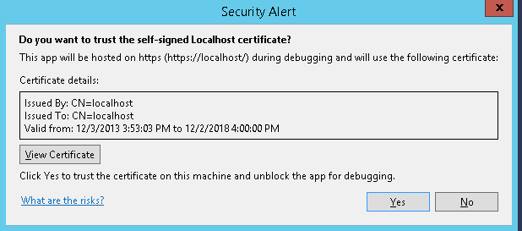

You may also be prompted to install the certificate, if so, click Yes.

Figure 2. Security warning: install certificate.

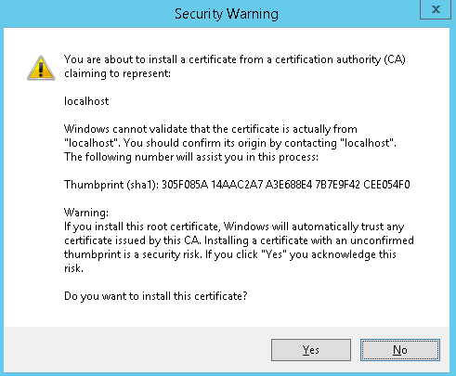

1. On the consent page to grant permissions to the app, select Trust It.

Figure 3. Grant app permissions

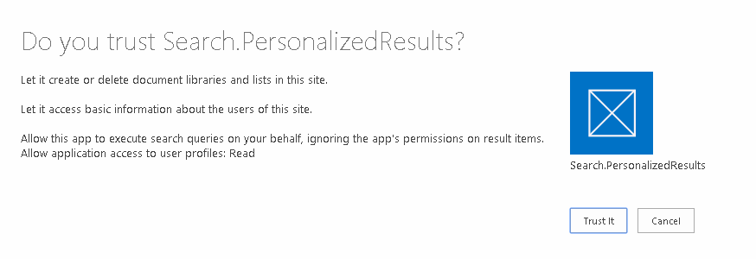

You should now see the app displayed in the browser.

Figure 4. Personalized search results app.

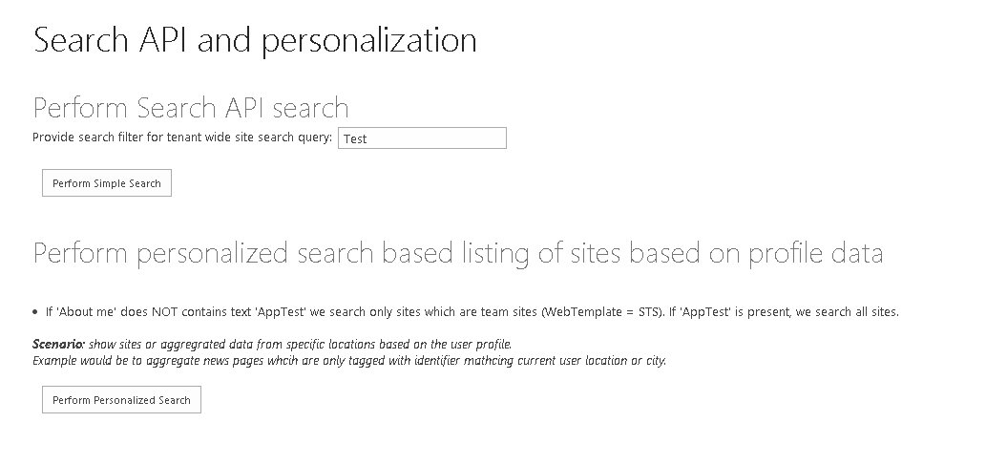

## Next steps

See [Deploying and installing apps for SharePoint: methods and options](http://msdn.microsoft.com/en-us/library/office/fp179933(v=office.15).aspx) for instructions on how to publish your app.

## Change log

First release.

## Related content

* [Using the SharePoint 2013 search Query APIs](http://msdn.microsoft.com/en-us/library/office/dn423226(v=office.15).aspx)
* [Search apps in SharePoint 2013](http://msdn.microsoft.com/en-us/library/office/dn554260(v=office.15).aspx)